**FPT ACADEMY INTERNATIONAL**



**FPT – APTECH COMPUTER EDUCATION**

Vertex System

|  |  |  |  |
| --- | --- | --- | --- |
| **Center Name:** | FPT – Aptech – HCM2 | | |
|  | Address:590 Cach Mang Thang Tam,  District 3, Ho Chi Minh City | | |
| **Instructor:** | Ms. Le Mong Thuy | | |
|  |  | | |
| **Class:** | T1.2010.E0 | | |
| **Group:** | 05 | | |
| **Group members** | **Name**  Pham Hung Lam | | **Student ID**  Student1280957 | |
|  | Nguyen Duc Trong | | Student1276113 | |
|  | Nguyen Vo Minh Tuan | | Student1283646 | |
|  |  | |  | |
| **Project Duration** | Start date | 15th dec 2020 | | |
|  | End date | 23th jan 2021 | | |

**This is to certify that**

#### **Mr.:**

Nguyen Duc Trong

Pham Hung Lam

Nguyen Vo Minh Tuan

**has successfully designed & developed**

eProject: Vertex System

**Submitted by:**

Nguyen Duc Trong

**Date of issue:** Dec 15th 2020

**Authorized Signature:**



**TABLE OF CONTENTS**

FPT – APTECH COMPUTER EDUCATION 1

ACKNOWLEGMENT 4

SYNOSIS 4

PROBLEM DEFINITION 4

CUSTOMER'S REQUIREMENTS SPECIFICATIONS (CRS) 5

Business/Project Objective: 5

Hardware/ Software Requirements: 6

SCOPE OF THE WORK (IN BRIEF) 7

Architecture and design of the system 8

Diagram of the website 9

TASK SHEET REVIEW 1 10

SITE MAP 11

MOCK OF THE WEBSITE 12

**1.** **Home** 12

**2.** **About Us** 13

**3.** **Types Of Virus** 14

**4.** **Year Wise Listing** 15

**5.** **Contact Us** 16

**6.** **Feedback** 17

TASK SHEET REVIEW 2 17

WEBSITE DESCRIPTION 23

**1.** **Home** 23

**2.** **About Us** 25

**3.** **Types Of Virus** 26

**4.** **Year Wise Listing** 27

**5.** **Contact Us** 29

**6.** **Feedback** 30

TASK SHEET REVIEW 3 30

# ACKNOWLEGMENT

On behalf of all the members of group 5, I would like to thank you all for the hard works, supports to make this eProject complete successfully. Especially, Ms. Le Mong Thuy, our teacher, she helped us a lot from the day that we started to study at FPT Aptech. With this eProject, she has guided us with her enthusiasm and rigorous, because of her guiding, we would be able to finish this project. Besides, I want to thank all the team member of group 5, each of the team member has been working continuously in 4 weeks in order to complete this project. The last but not least, we would like to say thank you to our family for always supporting us, creating the best conditions for us to focus on the project, and putting faith in the dreams we pursue.

# SYNOSIS

# The Vertex System needs to create a web page that meets the customer's need to find information about current popular viruses. Vertex System is a website that provides almost complete coverage of information viruses. In addition Vertex Express also provides a preventive and on-site repair. To with Vertex System everyone will have an overview of the virus.

# PROBLEM DEFINITION

Surely the keyword Virus is no longer something too strange for each of us, even making us worry and fear when thinking about it. They are all around us, all the time and all the time. Viruses have caused great damage to mankind. In recent times, many types of viruses have attacked people. Information about these viruses is fragmented. It is necessary to build a website with complete and appropriate information about these viruses.

The Vertex system wants to develop a website with pertinent information about different viruses. Their attack on the human system with appropriate symptoms, appropriate precautions and therapies (if any).

The website they requested is said to provide a user-friendly environment and navigation. Important menus should be listed at the top of the website. Also, a good look and color combination is expected.

Site will be developed for Windows Platform using HTML5, JavaScript, and Geolocation. The website will work well on all leading browsers including Chrome, IE, Firefox, etc.

# CUSTOMER'S REQUIREMENTS SPECIFICATIONS (CRS)

**Client: Vertex System**

### Business/Project Objective:

* + - The Vertex System wants to develop a website with pertinent information about different viruses. Their attack on the human system with appropriate symptoms, appropriate precautions and therapies (if any).
    - The website they requested is said to provide a user-friendly environment and navigation. Important menus should be listed at the top of the website. Also, a good look and color combination is expected.
    - Site will be developed for Windows Platform using HTML5, JavaScript, and Geolocation. The website will work well on all leading browsers including Chrome, IE, Firefox, etc.

**Input to the system:**

* Searching virus name, year of appearance, type, disease origin, sign and symptom.
* Feedback on the information avaiable on website.

**Output from the system:**

* A menu will categorize all functions of the site.
* Displays a list of Viruses that may be wisely available, accompanied by preventive measures, manifestations and origins.
* Viruses can be classified by origin, by year of appearance, by genetic code, ... all will be displayed separately.
* Do a search based on a specific: virus name, virus family name, origin, year of appearance, by code.
* Display viruses according to the highest level of danger.
* Displays detailed information of each virus.
* Provide information about the headquarters and branches of the vertex system.
* Website should have a brief introduction / history of vertex system in the Introduction page.
* Location of store in Contact page.

**Process**:

* Allows readers to study virus information and respond to information.
* Validate data input from users.

**Expected delivery date:** 25-Jan-2020.

**List of deliverables:**

* Document Word.
* User Guide.
* Source code.

### Hardware/ Software Requirements:

* **For developer**

**Hardware**

* + Intel Pentium 4 processor or higher
  + 1 Gigabytes of RAM or higher

**Software**

* + Windows 7 OS or higher
  + Adobe Dreamweaver
  + Web browsers such as IE, Chrome or Firefox are supporting HTML5, CSS3 and Javascript.
* **For web users**

**Hardware**

* + Intel Pentium 4 processor or higher
  + 512 Megabytes of RAM or higher

**Software**

* + Windows XP OS or higher
  + Web browsers such as IE, Chrome or Firefox are supporting HTML5, CSS3 and Javascript.

# SCOPE OF THE WORK (IN BRIEF)

After a long and detailed discussion, our group has decided to create a website contain the following webpages:

1. ***Homepage***: Display generally information about pandemic in the world and its affect on our society.
2. ***AboutUs***: Introduction about Vertex Express such as company size, specialties, location…
3. ***Types of Virus***: Give information about typical virus that causes pandemic in the world
4. ***Year wise listing***: Display contest, live show and upcoming event.
5. ***Contact Us***: Users can contact us via many means of communication include information of email, phone, address….
6. ***Feedback***: Allow users to write comments and give feedback to us.

# Architecture and design of the system

Webpage request



Requested Page

**RENDERING**

**ENGINE**

**CSS CODE**

**HTML CODE**

**WEB SERVER**

**WEB BROWSER**

**CLIENT**

**SERVER**

# Diagram of the website

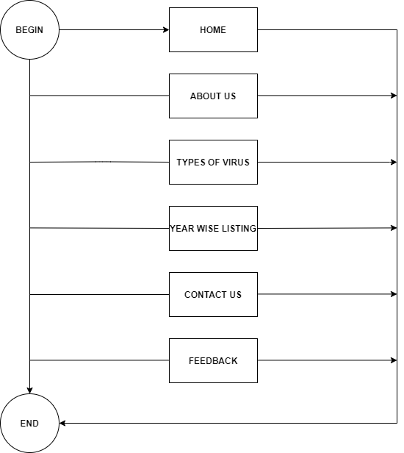



# TASK SHEET REVIEW 1

|  |  |  |  |  |  |  |  |
| --- | --- | --- | --- | --- | --- | --- | --- |
| **Project Ref. No.:**  **eP/Advertisement Portal Management**  **System/01** | | **Project Title:** | **Activity Plan Prepared By:** | **Date of Preparation of Activity Plan:** | | | |
| **Sr.**  **No.** | **Task** | **Actual**  **Start Date** | **Actual Days** | **Team**  **Mate Names** | **Status** |
| 1 | Problem Statement | VERTEX  SYSTEM | Trọng | 25-Dec-20 | 1 | Tuấn | Completed |
| 2 | Analysis of Vertex System requirements about the website | 25-Dec-20 | 1 | Tuấn | Completed |
| 3 | The scope of the work (in brief) | 25-Dec-20 | 1 | Trọng | Completed |
| 4 | Architecture and design of the system | 25-Dec-20 | 1 | Lâm | Completed |
| 5 | Diagram of the website | 25-Dec-20 | 1 | Lâm | Completed |
| 6 | Task Sheet | 25-Dec-20 | 1 | Trọng | Completed |

1 abc

|  |  |
| --- | --- |
| **Date: 25-Dec-2020** | |
| Signature of Instructor:  **Ms. Le Mong Thuy** | Signature of Team Leader:  **Nguyễn Đức Trọng** |

**SITE MAP**

**HOME**

**ABOUT**

**MENU**

**TYPES OF VIRUS**

**YEAR WISE LISTING**

**CONTACT**

**Mock of the website**

**1.Homepage**

**HEADER**

**LOGO - MENU**

**PICTURE SLIDESHOW**

|  |
| --- |
| **overview** |

|  |  |  |
| --- | --- | --- |
| **Images** | **VIRUS** | **CLASSIFICATION** |
| **SOURCE** | **PROTECT** |

|  |  |
| --- | --- |
| **VIRUS** | **VIDEO** |

|  |
| --- |
| **Classification base on** |

|  |  |  |  |  |
| --- | --- | --- | --- | --- |
| **The presence of nucleic acid** | **The structure or symmetry** | **The replication properties and site of repliation** | **The host range** | **The mode of transmission** |

|  |  |
| --- | --- |
| **image** | **source** |

|  |  |
| --- | --- |
| **protect** | **Images slide** |

|  |
| --- |
| **Some pictures of the virus’s influence** |

|  |
| --- |
| **Image Slide** |

|  |
| --- |
| **contact** |



**TASK SHEET REVIEW 2**



|  |  |  |  |  |  |  |  |
| --- | --- | --- | --- | --- | --- | --- | --- |
| **Project Ref. No.:**  **eP/Advertisement**  **Portal Management System/01** | | **Project Title:** | **Activity Plan Prepared By:** | **Date of Preparation of Activity Plan:** | | | |
| **Sr.**  **No.** | **Task** | **Actual Start Date** | **Actual Days** | **Team Mate Names** | **Status** |
| 1 | Site map | Vertex System | Nguyen  Duc  Trong | 04-Jan-20 | 1 | Trong | Completed |
| 2 | Mock of the website | 04-Jan-20 | 1 | Trong,Lam,Tuan | Completed |
| 3 | Task sheet | 04-Jan-20 | 1 | Trong | Completed |

|  |  |
| --- | --- |
| **Date: 04/01/2021** | |
| Signature of Instructor:  **Ms. Le Mong Thuy** | Signature of Team Leader :  **Mr.Nguyen Duc Trong** |

TABLE OF CONTENTS

**WEBSITE DESCRIPTION**

**1. Home page**

a description

This website displays the following information: Displays the site name and logo, images and defini, classification, source, protect virus’s information

b) Screenshot

|  |
| --- |
|  |
|  |

**Navigation bar**

**Description**

This menu bar allows users to navigate to all web pages of the entire site such as the home page, about us, type of virus, year wise listing, contact.

**2. About us**

**1. Description:**  
Display information for web page.

**2. Screenshot:**

|  |
| --- |
|  |
|  |
|  |
|  |

**3.TYPE OF VIRUS**

**1. Description:**

Displays information about classification virus, menu type of virus

**2. Screenshot:**

|  |
| --- |
|  |
|  |
|  |

**4.DETAIL TYPE OF VIRUSES:**

**1. Description:**

**Display information detail virus**

**2. Screenshot:**

|  |
| --- |
|  |
|  |

**5.YEAR WISE LISTING:**

**1. Description:**

**Display information virus order by year**

**2. Screenshot:**

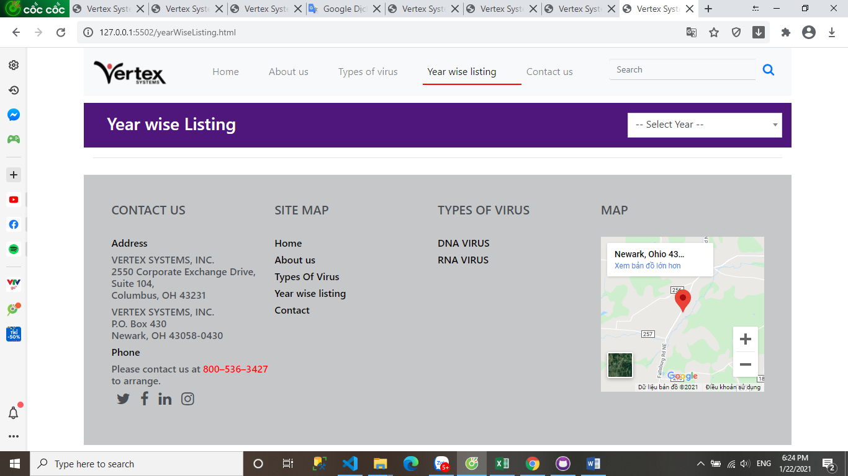

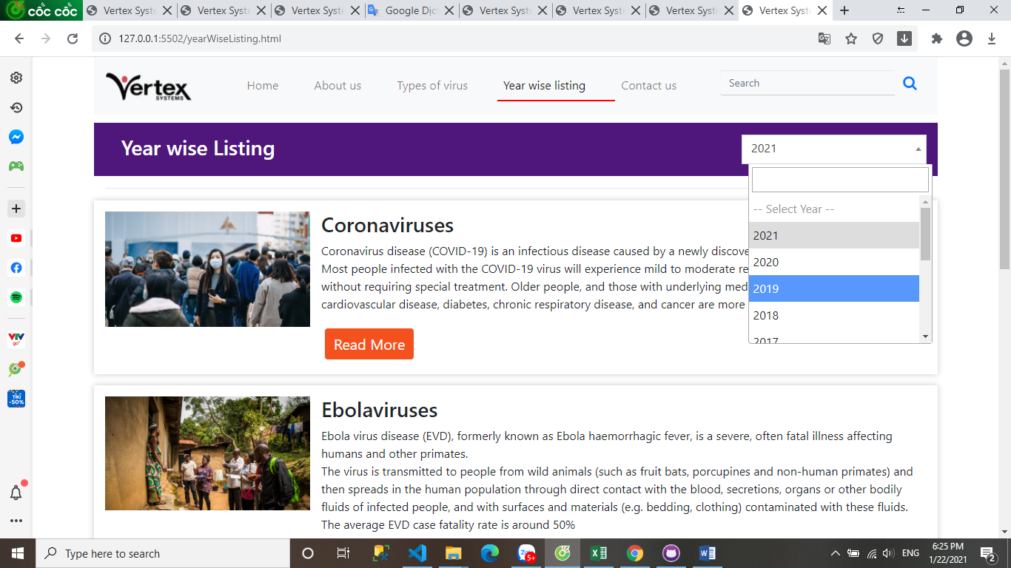

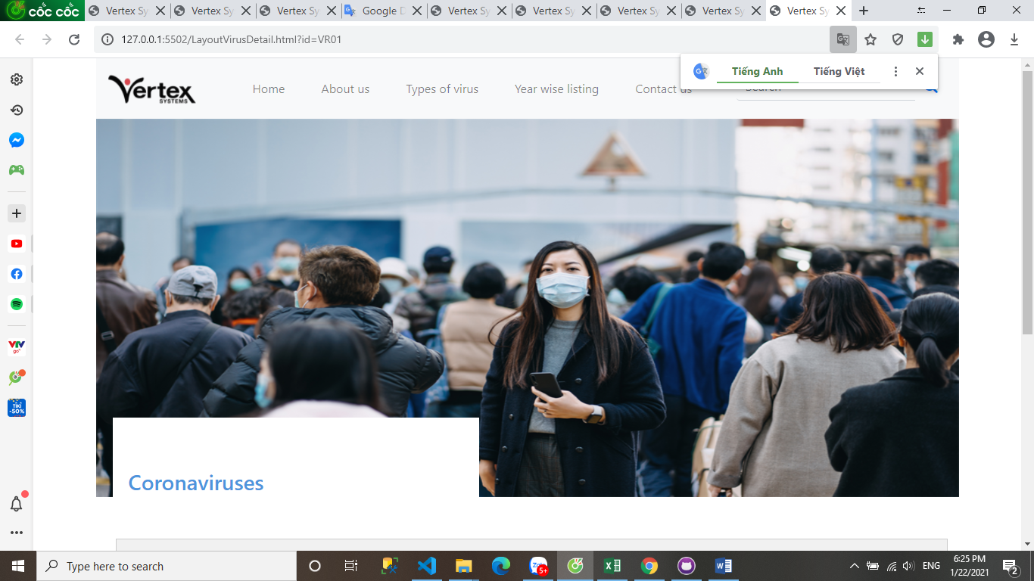

**6.SEARCHING:**

**1. Description:**

**Display information result user search**

**2. Screenshot:**

# 

**7.CONTACT:**

**1. Description:**

**Display form feedback**

**2. Screenshot:**

# 

# TASK SHEET REVIEW 3

|  |  |  |  |  |  |  |  |
| --- | --- | --- | --- | --- | --- | --- | --- |
| **Project Ref. No.: eP/Advertisement Portal Management System/01** | | **Project Name** | **Activity Plan Prepared By** | **Date of Preparation of Activity Plan:** | | | |
| **Sr./No.** | **Task** | **Actual Start Date** | **Actual Days** | **Team member name** | **Status** |
| 1 | HOME PAGE | Vertex Systems | Trong | 05-Jan-21 | 1 | Trong | Completed |
| 2 | About us, contact | 05- Jan -21 | 1 | Tuan | Completed |
| 3 | Year wise listing | 05- Jan -21 | 1 | Trong | Completed |
| 4 | Type of virus, search | 05- Jan -21 | 1 | Trong | Completed |
| 5 | Detail Virus |  |  | 05- Jan -21 | 1 | Lam,Trong | Completed |

|  |  |
| --- | --- |
| **Date:15/01/2021** | |
| Signature of Instructor:  **Ms. Le Mong Thuy** | Signature of Team Leader:  **Nguyen Duc Trong** |

# 